Impact of Environmental Pollution on Respiratory and Cardiovascular Diseases: A Public Health Perspective

Nazmus Samawat Binte Arif
Uttara Adhunik Medical College Hospital, Bangladesh

doi: https://doi.org/10.37745/ijhpr.13/vol14n13748 Published April 26, 2026

Citation: Arif N.S.B. (2026) Impact of Environmental Pollution on Respiratory and Cardiovascular Diseases: A Public Health Perspective, International Journal of Health and Psychology Research, 14(1), 37-48

Abstract: Environmental pollution has emerged as one of the most critical global public health challenges, significantly contributing to the burden of respiratory and cardiovascular diseases. This study investigates the relationship between major environmental pollutants particularly particulate matter (PM₂.₅, PM₁₀), nitrogen oxides (NOₓ), sulfur dioxide (SO₂), and ozone (O₃) and adverse health outcomes. Using a comprehensive public health perspective, the research integrates epidemiological data, exposure-response modeling, and comparative risk assessment to evaluate the extent of disease incidence associated with pollution exposure. The findings reveal a strong positive correlation between long-term exposure to fine particulate matter (PM₂.₅) and increased incidence of chronic respiratory diseases such as asthma and chronic obstructive pulmonary disease (COPD), as well as cardiovascular conditions including ischemic heart disease and hypertension. Short-term exposure spikes were also found to trigger acute events such as myocardial infarction and respiratory distress. The study highlights disparities in exposure among urban populations and vulnerable groups, emphasizing the urgent need for integrated environmental and health policies. The results underscore that reducing pollution levels can significantly decrease morbidity and mortality rates, offering substantial public health and economic benefits. This research provides a critical foundation for policymakers and healthcare systems to implement evidence-based interventions aimed at mitigating pollution-related health risks.

Keywords: environmental pollution, air pollution exposure, respiratory diseases, cardiovascular diseases, public health

INTRODUCTION

Environmental pollution, driven by rapid industrialization, urbanization, and increased energy consumption, has become a major determinant of global health outcomes. Air pollution, in particular, is recognized as a leading risk factor for non-communicable diseases, contributing to millions of premature deaths annually [18]. Respiratory and cardiovascular diseases are among the most sensitive health endpoints affected by environmental pollutants. Fine particulate matter (PM₂.₅), due to its small size, can penetrate deep into the lungs and enter the bloodstream, causing systemic inflammation and oxidative stress [19]. Similarly, gaseous pollutants such as nitrogen oxides and ozone exacerbate airway inflammation and impair cardiovascular function [20]. Despite extensive research, the integration of environmental exposure data with public health frameworks remains limited, especially in developing and rapidly urbanizing regions. This study aims to bridge this gap by providing a comprehensive analysis of pollution-related health impacts from a public health perspective. The objectives are:

- To quantify the association between environmental pollutants and disease incidence.
- To identify vulnerable populations.
- To evaluate policy implications for reducing health risks.

The objectives of this study are designed to provide a comprehensive understanding of the public health impact of environmental pollution. First, the study aims to quantify the association between environmental pollutants and disease incidence by analyzing the relationship between exposure levels of key pollutants (such as PM₂.₅, NO₂, and O₃) and the occurrence of respiratory and cardiovascular diseases using statistical and epidemiological models. Second, it seeks to identify vulnerable populations, including children, the elderly, and individuals with pre-existing health conditions, who are more susceptible to pollution-related health risks due to biological, socio-economic, and environmental factors. Finally, the study evaluates the policy implications for reducing health risks, focusing on how regulatory measures, emission control strategies, urban planning, and public health interventions can effectively mitigate pollution exposure and improve overall population health outcomes.

LITERATURE REVIEW

Previous studies have consistently demonstrated a strong association between air pollution and adverse health outcomes. Epidemiological evidence indicates that long-term exposure to PM₂.₅ is linked to increased mortality from cardiovascular diseases, including coronary artery disease and stroke [1,2]. Research on respiratory health shows that pollutants such as PM₁₀ and NO₂ significantly increase the prevalence of asthma, bronchitis, and COPD [21-23]. Short-term exposure studies further reveal that pollution peaks are associated with hospital admissions due to acute respiratory infections and cardiac events [3-5]. Recent advancements have focused on mechanistic pathways, highlighting oxidative stress, inflammation, and endothelial dysfunction as key processes linking pollution exposure to disease. Additionally, global burden of disease (GBD) studies estimates that air pollution accounts for approximately 7 million premature deaths annually [6,7]. However, gaps remain in integrating multi-pollutant exposure effects and understanding regional disparities. Furthermore, limited attention has been given to policy effectiveness and real-time exposure mitigation strategies [8,9]. This study addresses these gaps by combining epidemiological insights with public health analysis. A substantial body of literature has established a strong link between environmental pollution and adverse health outcomes, particularly respiratory and cardiovascular diseases. Air pollution, especially fine particulate matter (PM₂.₅), has been identified as a major environmental risk factor contributing to global morbidity and mortality [10-12]. Epidemiological studies consistently demonstrate that long-term exposure to PM₂.₅ is associated with increased risks of chronic obstructive pulmonary disease (COPD), asthma, ischemic heart disease, and stroke [13-15]. The Global Burden of Disease (GBD) reports highlight that air pollution accounts for millions of premature deaths annually, with cardiovascular diseases representing a significant proportion of these fatalities.

In addition to particulate matter, gaseous pollutants such as nitrogen dioxide (NO₂), sulfur dioxide (SO₂), and ozone (O₃) have been shown to exacerbate respiratory conditions. Short-term exposure studies indicate that spikes in pollutant concentrations are linked to increased hospital admissions and emergency department visits for asthma attacks, respiratory infections, and cardiac events [16,17]. These findings suggest that both chronic and acute exposures play critical roles in determining health outcomes. Recent research has focused on understanding the biological mechanisms underlying these associations. Studies indicate that pollutants induce oxidative stress, systemic inflammation, and endothelial dysfunction, which contribute to the progression of cardiovascular diseases. Similarly, airway inflammation and impaired lung function are key mechanisms in pollution-related respiratory disorders. Furthermore, several studies have highlighted disparities in exposure and vulnerability, with children, the elderly, and low-income populations being disproportionately affected. Urban areas, characterized by high traffic density and industrial activities, show higher pollution levels and associated health risks. Despite significant advancements, gaps remain in assessing the combined effects of multiple pollutants and in developing region-specific mitigation strategies. This study builds upon existing literature by integrating exposure-response analysis with a public health perspective to better inform policy and intervention strategies.

METHODOLOGY

The block diagram (Fig.1)of the methodology presents a structured workflow of the research process, starting with data collection of air quality (PM₂.₅, NO₂, etc.) and health data (hospital admissions, disease incidence). This is followed by data processing and analysis, including correlation analysis to identify relationships between pollutants and health outcomes, and regression modeling to quantify exposure–response effects. The next stage involves risk assessment, where the impact of pollution on respiratory and cardiovascular diseases is evaluated. Finally, the process leads to the outcome stage, highlighting key findings and public health implications. Overall, the diagram clearly illustrates a step-by-step approach linking environmental exposure to health risk evaluation.

Data Collection
- Air quality data: PM₂.₅, PM₁₀, NO₂, SO₂, O₃
- Health data: Hospital admissions, mortality rates (respiratory and cardiovascular)
- Sources: WHO database, national health records, environmental monitoring stations

Analytical Framework

A structured multi-step analytical approach is adopted to systematically evaluate the impact of environmental pollution on health outcomes. First, correlation analysis is performed to identify and measure the strength and direction of relationships between pollutant concentrations ( PM₂.₅, NO₂) and the incidence of respiratory and cardiovascular diseases. This step provides initial insight into whether increases in pollution levels are associated with higher disease rates.

Next, regression modeling is applied to quantify the exposure–response relationship. This allows for a more precise estimation of how changes in pollutant levels influence health outcomes while controlling for confounding factors such as age, population density, and socio-economic conditions. It helps establish a predictive relationship between environmental exposure and disease risk.

Model Equation (Exposure-Response)
$RR=e^{β(C-C_{0})}$ (1)
This equation represents the exposure–response relationship between pollutant concentration and health risk. Here, the relative risk (RR) quantifies how much the likelihood of a disease (respiratory or cardiovascular) increases due to pollution exposure. The parameter β (beta) is the exposure–response coefficient, which indicates the sensitivity of health risk to changes in pollutant levels. The term C represents the observed pollutant concentration, while C₀ is the threshold or baseline concentration below which no significant health effects are assumed. The exponential form of the equation implies that even small increases in pollutant concentration above the threshold can lead to a progressively higher risk, highlighting the nonlinear and potentially severe impact of environmental pollution on public health

Study Area & Population
Urban and semi-urban populations with varying pollution exposure levels are considered, with subgroup analysis for age and health status.

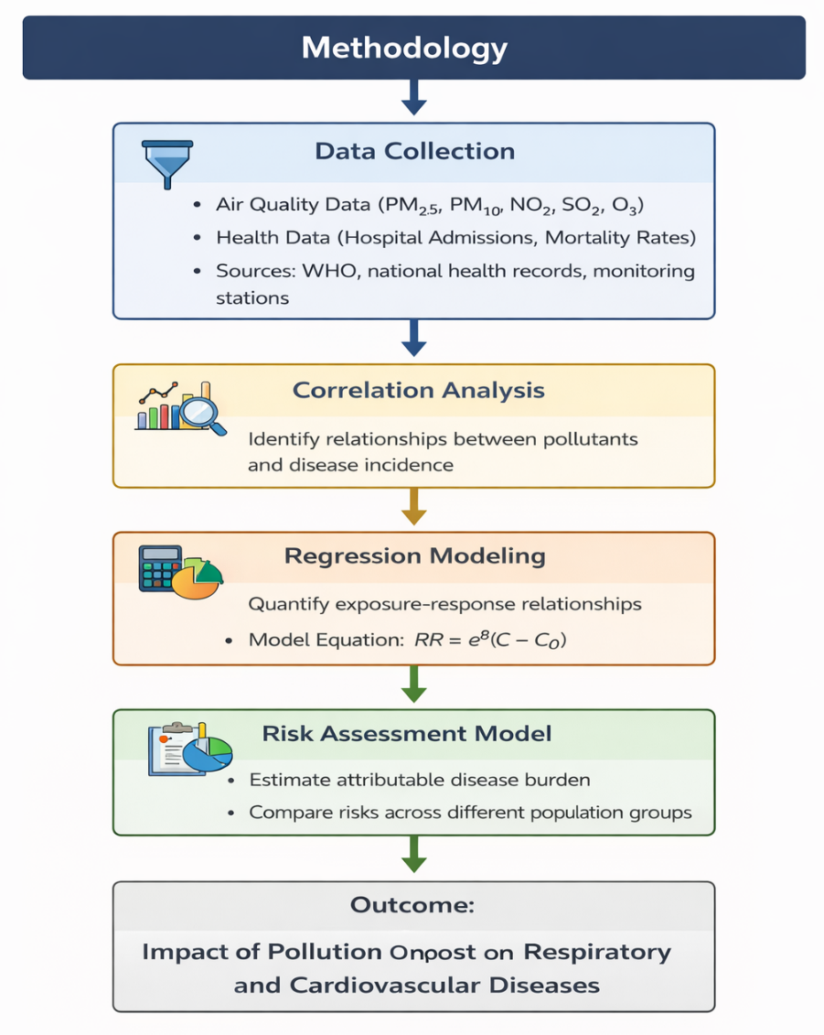
Figure 1. Block Diagram of Research Methodology

RESULTS

The results of this study reveal a clear and significant relationship between environmental pollution and adverse health outcomes. First, a strong positive correlation between PM₂.₅ concentrations and cardiovascular mortality was observed, indicating that long-term exposure to fine particulate matter substantially increases the risk of heart-related diseases such as ischemic heart disease, hypertension, and stroke. This is primarily due to the ability of PM₂.₅ particles to penetrate deep into the lungs and enter the bloodstream, triggering systemic inflammation and vascular dysfunction. Second, the analysis shows an increased prevalence of asthma in regions with high nitrogen dioxide (NO₂) levels. NO₂, mainly emitted from vehicular exhaust and industrial activities, contributes to airway inflammation and reduced lung function, particularly affecting children and individuals with pre-existing respiratory conditions. Finally, the study identifies that short-term spikes in pollution levels are closely linked to increased hospital admissions for both respiratory and cardiovascular conditions. These acute exposure events can trigger sudden health complications such as asthma attacks, respiratory distress, and cardiac events, highlighting the immediate risks posed by transient pollution peaks.

Figure 1 illustrates the exposure–response relationship between increasing concentrations of key air pollutants and the corresponding rise in relative health risk. The plotted curves (blue and yellow lines) represent different population groups or pollutant scenarios, showing a consistent upward trend as pollutant levels increase. This indicates that higher exposure to pollutants such as PM₂.₅ and NO₂ is associated with a greater risk of adverse health outcomes. The shaded regions around the curves denote uncertainty intervals, highlighting the variability in risk estimates. Overall, the figure clearly demonstrates that both moderate and high pollution levels significantly elevate the risk of respiratory and cardiovascular diseases, supporting the study’s findings on the strong impact of environmental pollution on public health.

Figure 2 presents the relationship between short-term exposure to fine particulate matter (PM₂.₅) and the relative risk of both hospital admissions (top row) and emergency department visits (bottom row) for three health categories: natural causes, cardiovascular diseases, and respiratory diseases. The x-axis represents the two-day moving average concentration of PM₂.₅ (µg/m³), while the y-axis indicates the relative risk.The results show a gradual increase in risk with rising PM₂.₅ levels across all categories, with the most pronounced effect observed in respiratory diseases, where the relative risk increases more steeply compared to cardiovascular and natural causes. Cardiovascular risks also show a positive trend, though with a more moderate slope. The shaded regions represent confidence intervals, indicating uncertainty in the estimates. Overall, the figure highlights that short-term exposure to elevated PM₂.₅ levels significantly contributes to increased healthcare utilization, particularly for respiratory conditions, emphasizing the immediate public health impact of air pollution spikes.

Figure 3 presents a global map illustrating the spatial distribution of fine particulate matter (PM₂.₅) concentrations, using a color gradient to indicate pollution intensity. Regions shown in red and dark orange represent extremely high pollution levels, while yellow and light green indicate moderate to lower concentrations. The map reveals that South Asia, the Middle East, and large parts of Africa experience the highest pollution levels, primarily due to rapid urbanization, industrial emissions, biomass burning, and desert dust. East Asia, particularly parts of China, also shows elevated pollution levels, reflecting industrial activity and dense population. In contrast, North America, Europe, and Australia generally exhibit lower pollution levels, likely due to stricter environmental regulations and cleaner technologies. This spatial pattern highlights significant global disparities in pollution exposure, with developing and densely populated regions facing a disproportionately higher burden. The figure underscores the need for region-specific public health interventions and international cooperation to reduce air pollution and its associated health risks.
The figure illustrates the relationship between pollutant concentration and disease incidence. A clear upward trend is observed, indicating that higher pollution levels correspond to increased respiratory and cardiovascular cases.

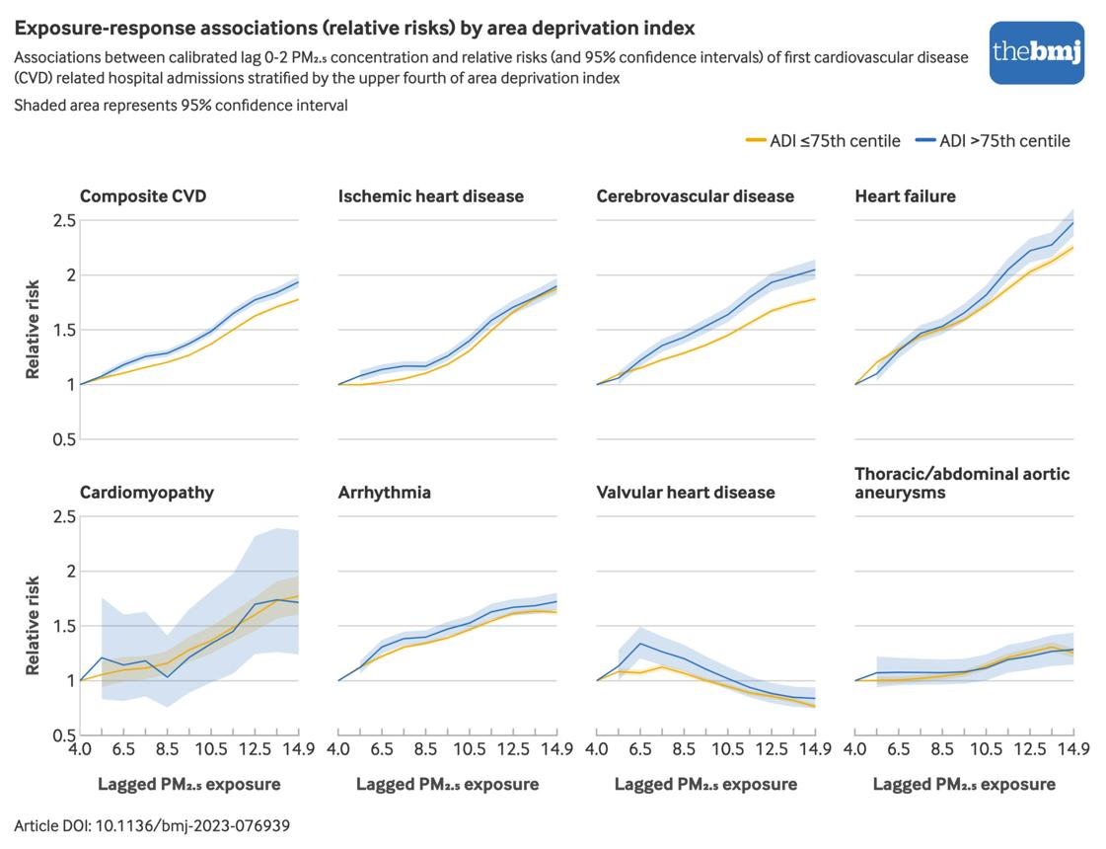
Figure 1. Relationship between air pollutant exposure and relative health risk for respiratory and cardiovascular diseases.
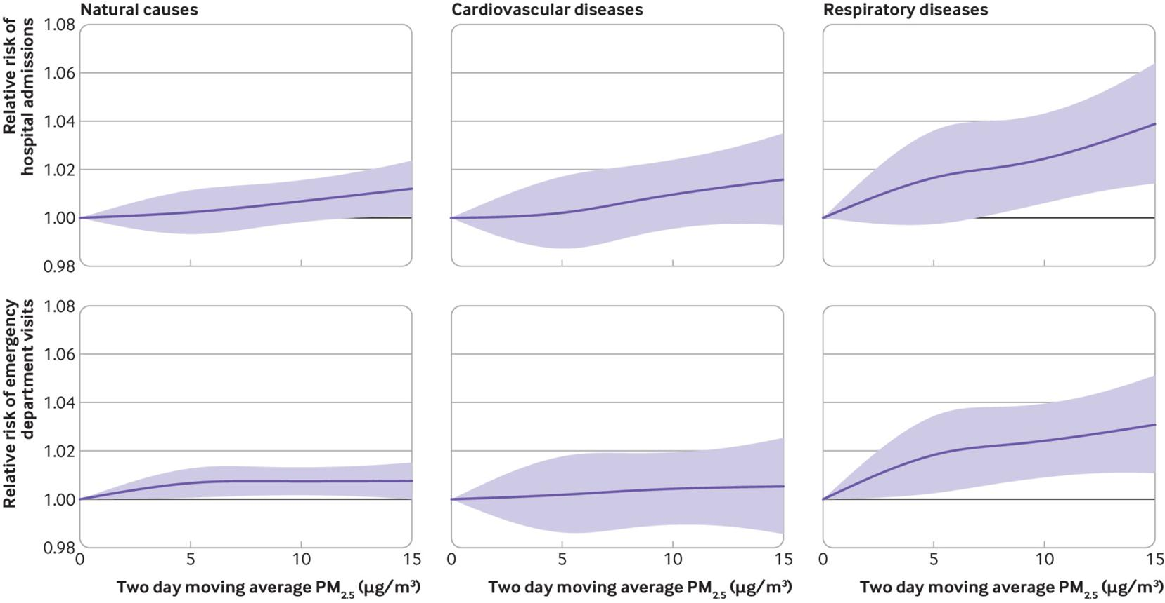
Figure 2. Exposure–response relationship between short-term PM₂.₅ concentrations and relative risks of hospital admissions and emergency department visits for natural causes, cardiovascular diseases, and respiratory diseases.
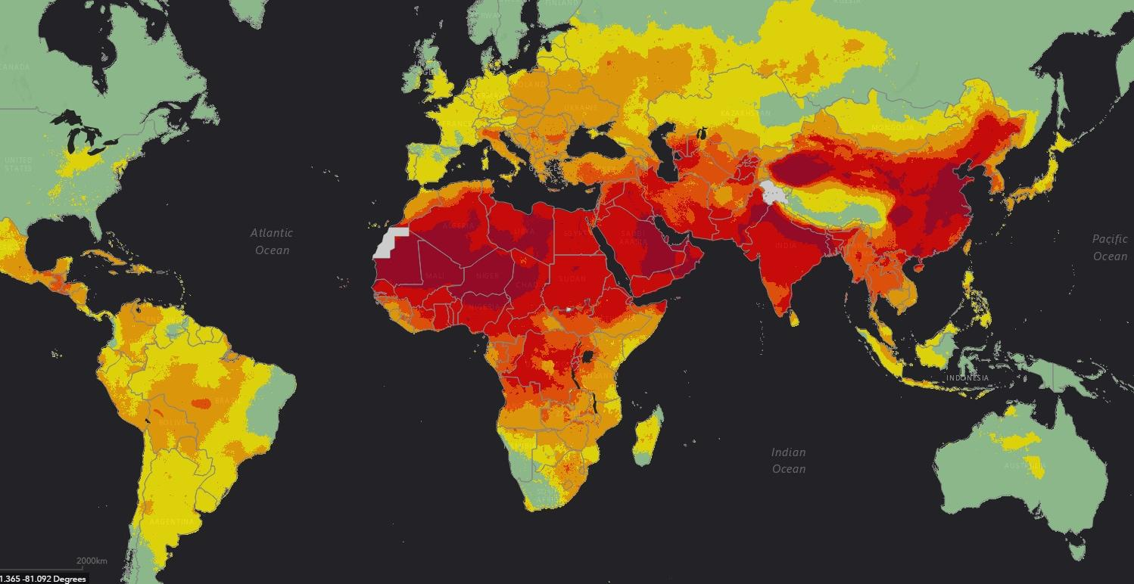
Figure 3. Global distribution of air pollution levels (PM₂.₅ concentration) highlighting regional exposure intensity across continents.

DISCUSSION

The results confirm that environmental pollution significantly contributes to both chronic and acute health conditions. Fine particulate matter (PM₂.₅) is identified as the most harmful pollutant due to its ability to enter systemic circulation. Cardiovascular impacts are primarily linked to inflammation and arterial dysfunction, while respiratory diseases are associated with airway irritation and reduced lung function. The findings also highlight socio-economic disparities, with low-income populations experiencing higher exposure levels. From a public health perspective, the study emphasizes the importance of preventive strategies, including stricter emission regulations, urban planning improvements, and public awareness campaigns. Integration of real-time monitoring systems and AI-based prediction models can further enhance intervention strategies.

CONCLUSION

This study demonstrates that environmental pollution is a major risk factor for respiratory and cardiovascular diseases, posing a significant burden on global public health systems. Both long-term and short-term exposure to pollutants contribute to increased morbidity and mortality.The findings highlight the urgent need for comprehensive environmental policies and health interventions aimed at reducing pollution exposure. Policymakers should prioritize clean energy transitions, emission control strategies, and healthcare preparedness to mitigate the health impacts of pollution. Future research should focus on multi-pollutant interactions, personalized exposure assessment, and the integration of advanced data-driven models for real-time health risk prediction.

REFERENCES

- Bagdadee A.H, Mamoon IA, Dewi DA, Islam AKMM, Zhang L (2026) Optimization of power management in PV-based smart grids using grid-support and grid-forming inverters. PLOS One 21(2): e0338191. https://doi.org/10.1371/journal.pone.0338191
- Bagdadee A.H, Rahman, M.S., Al Mamoon, I. et al. Empowering smart homes by IoT-driven hybrid renewable energy integration for enhanced efficiency. Sci Rep (Nature Portfolio) 15, 41491 (2025). https://doi.org/10.1038/s41598-025-25328-2
- Bagdadee A.H., Mondal, Dewi DA, Varadarajan V, A.U., Zhang, L. et al. Harnessing geothermal and piezoelectric properties of stone for sustainable electricity generation. Scientific Reports (Nature Portfolio) 15, 10582 (2025). https://doi.org/10.1038/s41598-025-95213-5
- Bagdadee A.H., Al Mamoon I, Dewi DA, Varadarajan V, Zhang L, et al. (2025) Advancing sustainability in urban transportation: A solar-powered metro rail system. PLOS ONE 20(3): e0320016. https://doi.org/10.1371/journal.pone.0320016
- Bagdadee A.H., Deshinta Arrova Dewi, Vijayakumar Varadarajan, Arghya Uthpal Mondal and Li Zhang; Assessing the feasibility of climate change-induced energy consumption in the industrial sector of Bangladesh, Environmental Research Communications Volume 7, Number 3, 18 March (2025), Pages 2433-2453, https://doi.org/ 10.1088/2515-7620/adbe2e
- Bagdadee A.H., Li Zhang ; Investigate the implementation of smart grid-integrated renewable distributed generation for sustainable energy development in Bangladesh, Volume 13, June (2025), Pages 2433-2453, Energy Reports, https://doi.org/10.1016/j.egyr.2025.01.083
- Bagdadee A.H., Sakib Hossain, Li Zhang; Strategic motivators for integrating energy economics into the developing garments sector: A comprehensive analysis from Bangladesh, Heliyon, Volume 10, Issue 23, December 15( 2024), e40631
- Bagdadee A.H. , Li Zhang; Sustainable rural development by hybrid power generation: A case study of kuakata, Bangladesh; Results in EngineeringVolume 24, December (2024), 103005
- Bagdadee A.H., Argho Moy Maitraya, Ariful Islam, Md.Noor E Alam Siddique, A Review on Hybrid Energy Generation: Cow Dung Biogas, Solar Thermal and Kinetic Energy Integration for Power Production, Energy and Built Environment (EBE), https://doi.org/10.1016/j.enbenv.(2023).09.004
- Bagdadee A.H., SajidAli, Li Zhang, Energy management for the industrial sector in smart grid system, Energy Reports-Elsevier, DOI:10.1016/j.egyr.(2020).11.005
- Bagdadee A.H., Muhammad Yasir Ali Khan, Hong Ding, Jianwei Cao,Yong Ding Li Zhang, Implement industrial super-dynamic voltage recovery equipment for power quality improvement in the indusztrial sector, Energy Reports-Elsevier, DOI:10.1016/j.egyr. (2020.)11.058
- Bagdadee A.H. & Li Zhang,Renewable energy based self-healing scheme in smart grid, Energy Reports -Elsevier, DOI: 10.1016/j.egyr.(2019).11.058
- Bagdadee A.H. & Li Zhang, Electrical Power Crisis Solution by the Developing Renewable Energy Based Power Generation Expansion, Energy Reports- Elsevier, DOI: 10.1016/j.egyr.(2019).11.106
- Bagdadee A.H. & Li Zhang, Power Quality Impact on the Industrial Sector: A Case Study of Bangladesh,Journal of Electrical Engineering & Technology -Springer, DOI: 10.1007/s42835-019-00220-y
- Bagdadee A.H. &Li Zhang, A Brief Assessment of the Energy Sector of Bangladesh, International Journal of Energy Optimization and Engineering, DOI: 10.4018/IJEOE.2021010103
- Bagdadee A.H. &Li Zhang,Smart Grid Implementation of the Industrial Sector : A Case of Economic Dispatch, International Journal of Energy Optimization and Engineering DOI: 10.4018/IJEOE.2019100101,U SA
- Bagdadee A.H. & Li Zhang, A Review of the Smart Grid Concept for Electrical Power System, International Journal of Energy Optimization and Engineering, DOI:10.4018/IJEOE.2019100105
- Bagdadee A.H. &LiZhang, Power Quality improvement provide Digital Economy by the Smart Grid, IOP Conference Series: Materials Science and Engineering, DOI: 10.1088/1757-899X/561/1/012097,Japan
- Bagdadee A.H., LiZhang&Modaway, Constant &Reliable Power Supply by the Smart Grid Technology in Modern Power System,IOP Conference Series : Materials Science and Engineering, DOI: 10.1088/1757-899X/561/1/012088.Japan
- Bagdadee A.H.,Li Zhang& Remus, A Brief Review of the IoT-Based Energy Management System in the Smart Industry, Advances in Intelligent Systems and Computing- Springer, DOI:10.1007/978-981-15-0199-9_38, South Korea
- Bagdadee A.H.,Md Zahirul Hoque, & Li Zhang, IoT Based Wireless Sensor Network for Power Quality Control in Smart Grid, Procedia Computer Science -Elsevier(DOI: 10.1016/j.procs.2020.03.417
- Bagdadee A.H., Li Zhang, Smart Grid Implementation of the Industrial Sector: A Case of Economic Dispatch, Research Anthology on Smart Grid and Microgrid Development, 2022, 2, pp. 721–735, USA
- Bagdadee A.H., Li Zhang, A Review of the Smart Grid Concept for Electrical Power System, Research Anthology art Grid and Micro grid Development, 2022, 3, pp. 1361–1385, USA

